|  |
| --- |
| BỘ GIÁO DỤC VÀ ĐÀO TẠOTRƯỜNG ĐẠI HỌC HOA SEN **KHOA CÔNG NGHỆ THÔNG TIN** |

BÁO CÁO

ĐỒ ÁN CUỐI KỲ SOFTWARE ENGINEER

**Tên đề tài:Trang Web quản lý của hàng câu lạc bộ**

**Giảng viên hướng dẫn : Cô Võ Thị Thu Hà**

**Nhóm sinh viên thực hiện : Trần Thanh Duy MSSV:22122714**

**:Đinh Quốc Cường MSSV: 22112897**

**:Tạ Minh Đức MSSV: 2191359**

**:Nguyễn Quốc Duy MSSV: 22011127**

**:Trần Hoàng Thiên MSSV: 2191042**

**Số nhóm : 2**

**THÁNG 12 / NĂM 2023**

**1.Software Process Model**

-The model we use in this process is Agile .Using the Agile software development process model, especially in the context of building an e-commerce website with MVC architecture, offers several advantages. Here are some reasons why Agile is a suitable choice:

* **Adaptability to Change:**
  + Agile emphasizes flexibility and responsiveness to change. In the dynamic environment of web development, requirements often evolve. Agile allows you to easily accommodate changes, ensuring that your web application remains aligned with evolving business needs.
* **Customer Collaboration:**
  + Agile encourages continuous customer involvement throughout the development process. This ensures that the product being built meets customer expectations and requirements. In an e-commerce website, user feedback is crucial for creating a positive and user-friendly shopping experience.
* **Incremental Development:**
  + Agile promotes incremental and iterative development. This means that you can deliver a working product in small, manageable increments. For an e-commerce website, this allows you to release new features or updates regularly, keeping the site current and competitive.
  + **Faster Time to Market:**
  + The iterative nature of Agile development allows for quicker delivery of a minimally viable product (MVP). This enables you to launch your e-commerce website sooner and start gaining user feedback and generating revenue while continuously improving and expanding the platform.
* **Collaborative Teamwork:**
  + Agile methodologies foster a collaborative and cross-functional team environment. This is particularly beneficial in a complex project like web development, where different skills (design, development, testing) need to work together seamlessly to produce a high-quality product.
* **Continuous Improvement:**
  + Agile incorporates regular retrospectives, where the team reflects on their performance and identifies areas for improvement. This continuous feedback loop contributes to the ongoing enhancement of the development process and the quality of the product.
* **Risk Management:**
* Agile allows for early identification and mitigation of risks. Regular reviews and evaluations during the development process help in identifying issues early on, reducing the likelihood of major problems later in the project.
* **Transparency:**
* Agile promotes transparency through open communication and regular demonstrations of working software. This ensures that stakeholders are well-informed about the project's progress and can provide valuable input.

1. **Project Plan**
2. **Software Requirements Specification**

|  |  |
| --- | --- |
| Use case | Content |
| Use-Case Name | Register |
| Describe | User account registration |
| Actor | Client users |
| Related Use-Cases | Log |
| Activation conditions | Visit Website |
| Pre-conditions | The user presses the registration button at the header.  The user presses the registration button at the login page.. |
| Post-conditional | Switch to otp authentication page when registration is successful.  Return a notice when registering for the wrong format. |
| Main event stream | 1. The user enters a student or staff number. 2. The user enters their full name. 3. The user enters the email. 4. The user enters a phone number. 5. The user enters the address. 6. The user enters a password. 7. The user presses the register button. |
| Secondary event streams | * 1. The user entered the wrong student or staff number.   2. The user incorrectly enters 5 tail numbers when compared to the 5 serial numbers of the student email.   3. The blank user doesn't fill in the student or staff number.   4. The blank user does not fill in his full name.   5. The blank user doesn't fill in the email.   6. The user incorrectly enters the last 5 digits of the student email number with the student number.   7. The blank user does not fill in the phone number.   8. The user left blank does not fill in the address.   9. The blank user does not fill in the password.   10. The user enters a password with less than 6 digits.   11. Switch to opt page if registration is successful   12. Error message if registration information is invalid |

Hình 1.Usecase Register

|  |  |
| --- | --- |
| Use case | Content |
| Use-Case Name | Log in |
| Describe | Log in to the user account. |
| Actor | Client users. |
| Related Use-Cases | Sign up. |
| Activation conditions | Go to the website. |
| Pre-conditions | The user presses the login button at the header.  The user presses the login button at the registration page. |
| Post-conditional | Switch to the home page if the login is successful.  Return a notification if you log in to the wrong account or password. |
| Main event stream | 1. The user enters the account as email. 2. The user imports the update. 3. The user presses the login button |
| Secondary event streams | * 1. Report an error if the user doesn't have an account.   2. Error message if user enters wrong account.   3. Error message if user enters wrong password. |

Hình 2.Usecase Login

Hình 3.Usecase Forgot Password

|  |  |
| --- | --- |
| Use case | Content |
| Use-Case Name | Forgot password |
| Describe | Password reset. |
| Actor | Client users. |
| Related Use-Cases | Edit user information. |
| Activation conditions | Go to the website. |
| Pre-conditions | The user presses the login button at the header.  The user presses the login button at the registration page. |
| Post-conditional | Switch to the forgotten password page. |
| Main event stream | 1. The user enters the email registered for the account. 2. The user presses the password reset button |
| Secondary event streams | * 1. User leaves the email registration box blank.s |

|  |  |
| --- | --- |
| Use case | Content |
| Use-Case Name | OTP confirmation |
| Describe | Validate the opt code to make sure the user email is correct. |
| Actor | Client users. |
| Related Use-Cases | Sign up, add user information. |
| Activation conditions | Successful registration at the registration page. |
| Pre-conditions | Successful registration at the registration page. |
| Post-conditional | Enter the correct OTP.  Enter the wrong OTP. |
| Main event stream | 1. Enter the OTP. |
| Secondary event streams | * 1. The user entered the wrong OTP.   2. The user leaves the OTP input box blank.   3. Failure to receive code may press the resubmit button. |

Hình 4.Usecase Validate OTP

|  |  |
| --- | --- |
| Use case | Content |
| Use-Case Name | Search for products. |
| Describe | Search for products that users need. |
| Actor | Customer users and administrators. |
| Related Use-Cases | Store |
| Activation conditions | Visit the website's store. |
| Pre-conditions | Visit the website's store. |
| Post-conditional | Pay out the products that customers need to find. |
| Main event stream | 1. Enter the product to be found in the product search box. 2. Press enter or the search icon button. |
| Secondary event streams | * 1. The product does not exist. |

Hình 5.Usecase Search Product

|  |  |
| --- | --- |
| Use case | Content |
| Use-Case Name | Filter products. |
| Describe | Filter each product type by the individual type that users need. |
| Actor | Customer users and administrators. |
| Related Use-Cases | Store |
| Activation conditions | Visit the website's store. |
| Pre-conditions | Visit the website's store. |
| Post-conditional | Pay out the types of products that customers need to find. |
| Main event stream | 1. Select the product filter box. 2. Select the product category type you want to search. |
| Secondary event streams |  |

Hình 6.Usecase Filter Product

|  |  |
| --- | --- |
| Use case | Content |
| Use-Case Name | Sort products. |
| Describe | Arrange products according to the requirements that users need such as arranging prices incrementally, decreasing floors, best-selling sales. |
| Actor | Customer users and administrators. |
| Related Use-Cases | Store |
| Activation conditions | Visit the website's store. |
| Pre-conditions | Visit the website's store. |
| Post-conditional | Pay out the types of products that customers need to find. |
| Main event stream | 1. Select the Sort products box. |
| Secondary event streams |  |

Hình 7.Usecase Sort Product

|  |  |
| --- | --- |
| Use case | Content |
| Use-Case Name | Abandon the product basket. |
| Describe | Put in the cart the products that customers want to rent. |
| Actor | Customer users and administrators. |
| Related Use-Cases | Abandon the product basket. |
| Activation conditions | Visit the website's store. |
| Pre-conditions | Successful logon to the user system. |
| Post-conditional | The product that the customer selects will be moved to the cart. |
| Main event stream | 1. Tap the add product button. |
| Secondary event streams | * 1. Select out-of-stock products. |

Hình 8.Usecase Abadon basket

|  |  |
| --- | --- |
| Use case | Content |
| Use-Case Name | Save favorite products |
| Describe | Save your favorite products. |
| Actor | Customer users and administration |
| Related Use-Cases | Save favorite products |
| Activation conditions | Visit the website's store. |
| Pre-conditions | Successful login to user system |
| Post-conditional | The product will be saved to the favorites section of the user's personal information. |
| Main event stream | 1. Tap the product favorites button. |
| Secondary event streams | * 1. The product has not been loved.   2. The product is already a favorite. |

Hình 9.Usecase Favourite Product

|  |  |
| --- | --- |
| Use case | Content |
| Use-Case Name | Abate |
| Describe | Reconfirm order and payment information. |
| Actor | Customer users and administrators. |
| Related Use-Cases | Abandon the product basket. |
| Activation conditions | Visit the website's store. |
| Pre-conditions | Successful logon to the user system. |
| Post-conditional | Abandoned basket of necessary products. |
| Main event stream | 1. The cart has no products put in. 2. Users enter their full name in the customer information box. 3. The user enters a student or staff number in the customer information box. 4. The user enters the recipient's phone number in the customer information box. 5. The user selects the pickup facility in the customer information pane. 6. The user selects the date and time of delivery in the customer information box. 7. The user enters a note if necessary in the customer information box. 8. The user presses the order button. |
| Secondary event streams | * 1. The user leaves a blank box. |

Hình 10.Usecase Abate

|  |  |
| --- | --- |
| Use case | Content |
| Use-Case Name | Management of personal information |
| Describe | Edit the customer's personal information. |
| Actor | Individual users |
| Related Use-Cases | Edit user information. |
| Activation conditions | Visit the website's store. |
| Pre-conditions | Successful logon to the user system. |
| Post-conditional | Go to the user's profile. |
| Main event stream | 1. Click the profile button in the navigation menu. 2. Click the edit information button. 3. Edit personal information including profile picture, full name, gender, phone number, address, faculty, industry. 4. Press the save information button. |
| Secondary event streams | * 1. The user is not logged on to the user system.   2. Leave the information boxes blank. |

Hình 11.Usecase Personal Information

|  |  |
| --- | --- |
| Use case | Content |
| Use-Case Name | Order Management |
| Describe | View the list of orders that have been ordered when the system has confirmed the order or has not confirmed the order. |
| Actor | Individual users. |
| Related Use-Cases | View the order list. |
| Activation conditions | Visit the website's store. |
| Pre-conditions | Successful logon to the user system. |
| Post-conditional | Go to the user's profile. |
| Main event stream | 1. Click the order history button at the navigation menu. |
| Secondary event streams | * 1. The user is not logged on to the user system. |

Hình 12.Usecase View All Order Management

|  |  |
| --- | --- |
| Use case | Content |
| Use-Case Name | Order Management |
| Describe | Delete previously ordered orders when the system has not confirmed the order. |
| Actor | Individual users. |
| Related Use-Cases | Delete an order. |
| Activation conditions | Visit the website's store. |
| Pre-conditions | Successful logon to the user system. |
| Post-conditional | Go to the user's profile. |
| Main event stream | 1. Click the order history button at the navigation menu. 2. Tap the delete order button or trash can icon at the order you want to delete. |
| Secondary event streams | * 1. The order has been confirmed. |

Hình 13.Usecase Delete Order Management

|  |  |
| --- | --- |
| Use case | Content |
| Use-Case Name | Order Management |
| Describe | View order details when the system has confirmed the order or has not confirmed the order. |
| Actor | Individual users. |
| Related Use-Cases | View the order list. |
| Activation conditions | Visit the website's store. |
| Pre-conditions | Successful logon to the user system. |
| Post-conditional | Go to the user's profile. |
| Main event stream | 1. Click the order history button at the navigation menu. 2. Tap the view order button or the eye icon at the order you want to view. |
| Secondary event streams | * 1. The user is not logged on to the user system. |

Hình 14.Usecase View Order Detail

|  |  |
| --- | --- |
| Use case | Content |
| Use-Case Name | Change password |
| Describe | Change the user password. |
| Actor | Individual users. |
| Related Use-Cases | Edit user information. |
| Activation conditions | Visit the website's store. |
| Pre-conditions | Successful logon to the user system. |
| Post-conditional | Go to the user's profile. |
| Main event stream | 1. Click the change password button at the navigation menu. 2. Enter the old password. 3. Enter the new password. 4. Press the change password button. |
| Secondary event streams | * 1. The user is not logged on to the user system.   2. Wrong old password.   3. The new password does not match the old password.   4. The new password is not shorter than 6 digits.   5. The password cells are blank. |

Hình 15.Usecase Change Password

|  |  |
| --- | --- |
| Use case | Content |
| Use-Case Name | View the product list. |
| Describe | View all products included in the system. |
| Actor | Administrative user. |
| Related Use-Cases | Product |
| Activation conditions | Visit the administrator's website. |
| Pre-conditions | Go to the product device management page. |
| Post-conditional | Show up the list. |
| Main event stream | 1. Tap the device button in the menu bar on the left to access the product device management page. |
| Secondary event streams |  |

Hình 16.Usecase View Product List

|  |  |
| --- | --- |
| Use case | Content |
| Use-Case Name | Add products. |
| Describe | Add a new product to the system. |
| Actor | Administrative user. |
| Related Use-Cases | Product |
| Activation conditions | Visit the administrator's website. |
| Pre-conditions | Go to the product device management page. |
| Post-conditional | Tap the add new product device button. |
| Main event stream | 1. Enter a new device name 2. Enter quantity 3. Enter a description (if necessary) 4. Select product images 5. Select a product status 6. Select product type 7. Enter price 8. Press the save new product button. |
| Secondary event streams | * 1. The new device name is matched with the names of the devices included in the system.   2. The image is not properly formatted in size.   3. The information boxes are blank.   4. The information is invalidly filled. |

Hình 17.Usecase Add Product

|  |  |
| --- | --- |
| Use case | Content |
| Use-Case Name | Edit the product. |
| Describe | Edit the product's information. |
| Actor | Administrative user. |
| Related Use-Cases | Product |
| Activation conditions | Visit the administrator's website. |
| Pre-conditions | Go to the product device management page. |
| Post-conditional | Tap the edit button of the product device you want to edit. |
| Main event stream | 1. Edit the information to correct 2. Click the save button to change the information you want to update. |
| Secondary event streams | * 1. Enter invalid information   2. Remove the forced info box |

Hình 18.Usecase Edit Product

|  |  |
| --- | --- |
| Use case | Content |
| Use-Case Name | See a list of product catalog types. |
| Describe | View all types of categories available in the system. |
| Actor | Administrative user. |
| Related Use-Cases | Directory |
| Activation conditions | Visit the administrator's website. |
| Pre-conditions | Go to your catalogue management page. |
| Post-conditional | Show up the list. |
| Main event stream | 1. Tap the catalogue button in the menu bar on the left to access your catalogue management page. |
| Secondary event streams |  |

Hình 19.Usecase View Catalog types

|  |  |
| --- | --- |
| Use case | Content |
| Use-Case Name | Add a product type category. |
| Describe | Add a new category to the system. |
| Actor | Administrative user. |
| Related Use-Cases | Directory |
| Activation conditions | Visit the administrator's website. |
| Pre-conditions | Go to your catalogue management page. |
| Post-conditional | Tap the add new category button. |
| Main event stream | 1. Enter a new category name 2. Press the save new category button. |
| Secondary event streams | * 1. The new category names are identical to the names of the categories included in the system.   2. Remove the category name box. |

Hình 20. Usecase Add Product Type Category

|  |  |
| --- | --- |
| Use case | Content |
| Use-Case Name | Edit a product type category. |
| Describe | Edit your catalogue's information again. |
| Actor | Administrative user. |
| Related Use-Cases | Directory |
| Activation conditions | Visit the administrator's website. |
| Pre-conditions | Go to your catalogue management page. |
| Post-conditional | Tap the edit button of the category type you want to edit. |
| Main event stream | 1. Edit the information to edit. 2. Click the save button to change the information you want to update. |
| Secondary event streams | * 1. Enter invalid information.   2. Remove the information box. |

Hình 21. Usecase Edit Product Type Category

|  |  |
| --- | --- |
| Use case | Content |
| Use-Case Name | See a list of invoices. |
| Describe | View all existing invoices in the system. |
| Actor | Administrative user. |
| Related Use-Cases | Invoice management |
| Activation conditions | Visit the administrator's website. |
| Pre-conditions | Go to the billing management page. |
| Post-conditional | Show up the list. |
| Main event stream | 1. Click the invoice button in the menu bar on the left to access the invoice management page. |
| Secondary event streams |  |

Hình 22.Usecase List Of Invoice

|  |  |
| --- | --- |
| Use case | Content |
| Use-Case Name | Filter the status of invoices. |
| Describe | Filter each type of invoice by the individual status that users want to see. |
| Actor | Administrative user. |
| Related Use-Cases | Invoice management |
| Activation conditions | Visit the administrator's website. |
| Pre-conditions | Go to the billing management page. |
| Post-conditional | Show up the list. |
| Main event stream | 1. Select the invoice filter box. 2. Select the invoice status that you'd like to view. |
| Secondary event streams | * 1. There are no bills. |

Hình 23.Usecase Filter Status Of Invoice

|  |  |
| --- | --- |
| Use case | Content |
| Use-Case Name | Edit your invoice. |
| Describe | Edit your invoice's information again |
| Actor | Administrative user. |
| Related Use-Cases | Invoice management |
| Activation conditions | Visit the administrator's website. |
| Pre-conditions | Go to the billing management page. |
| Post-conditional | Tap the edit button of the invoice you want to edit. |
| Main event stream | 1. Edit the information to edit. 2. Click the save button to change the information you want to update. |
| Secondary event streams | * 1. Enter invalid information.   2. Remove the information box. |

Hình 24.Usecase Edit Invoice

|  |  |
| --- | --- |
| Use case | Content |
| Use-Case Name | View invoice details. |
| Describe | View details of products in your invoice |
| Actor | Administrative user. |
| Related Use-Cases | Invoice management |
| Activation conditions | Visit the administrator's website. |
| Pre-conditions | Visit the specific invoice page. |
| Post-conditional | Tap the edit button to see the products in that invoice. |
| Main event stream | 1. Press the view invoice button or edit button to view a customer's invoice that includes the products in the invoice. |
| Secondary event streams |  |

Hình 25.Usecase View Invoice Detail

|  |  |
| --- | --- |
| Use case | Content |
| Use-Case Name | Edit invoice details. |
| Describe | Edit the information of an order of a product in the order. |
| Actor | Administrative user. |
| Related Use-Cases | Invoice management |
| Activation conditions | Visit the administrator's website. |
| Pre-conditions | Visit the specific invoice page. |
| Post-conditional | Tap the edit button of a product in the invoice. |
| Main event stream | 1. Update the information. 2. Click the save the information you want to update button |
| Secondary event streams | * 1. Leave the binding cells blank.   2. Fill in invalid information. |

Hình 26.Usecase Edit Invoice Detail

|  |  |
| --- | --- |
| Use case | Content |
| Use-Case Name | View the list of registered users. |
| Describe | View the information of all existing registered users in the system. |
| Actor | Administrative user. |
| Related Use-Cases | Member |
| Activation conditions | Visit the administrator's website. |
| Pre-conditions | Go to your member management page. |
| Post-conditional | Show up the list. |
| Main event stream | 1. Click the members button in the menu bar on the left to access the member information management page. |
| Secondary event streams |  |

Hình 27.Usecase View List Registered

|  |  |
| --- | --- |
| Use case | Content |
| Use-Case Name | Edit member information. |
| Describe | Edit the information of a member account. |
| Actor | Administrative user. |
| Related Use-Cases | Member |
| Activation conditions | Visit the administrator's website. |
| Pre-conditions | Go to your member management page. |
| Post-conditional | Tap the info button or the information icon of the specific user. |
| Main event stream | 1. Update customer information again. 2. Click the save the updated information button. |
| Secondary event streams |  |

Hình 28.Usecase Edit Member Information

1. 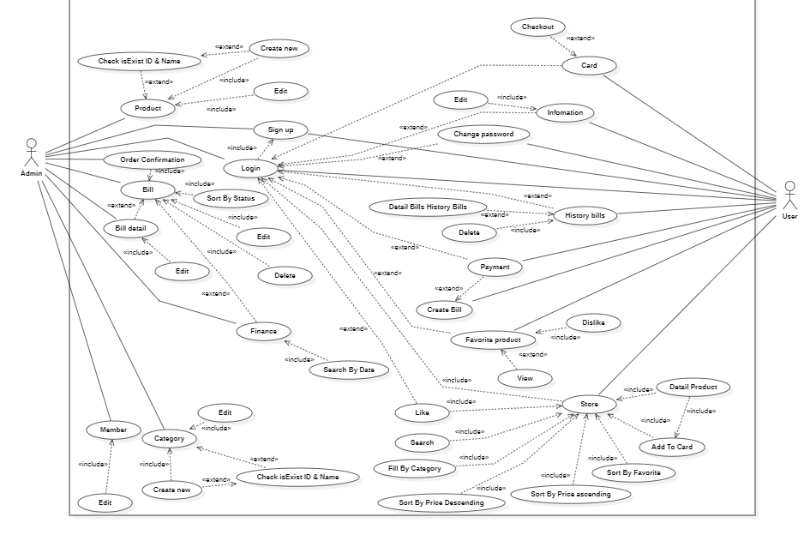Usecase diagram and Class diagram

4.1 Usecase Diagram

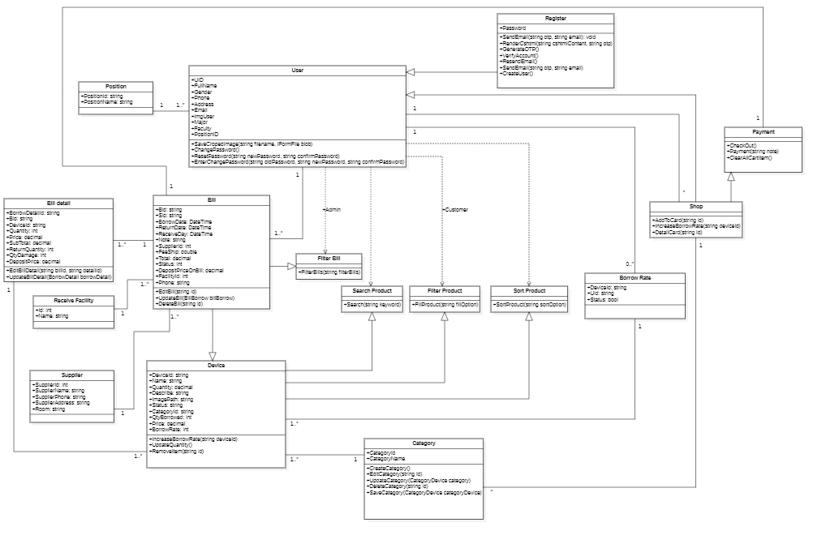

Hình 29.FullSize Class Diagram